LIGHT AND THE COLOR WHITE
First, a few basics about light.
Light is a form of electromagnetic radiation, that behaves as a wave, detected by the human eye. Of the two types of cells in the retina the cones are responsible for color detection. There are three types of cones, those that detect red, those that detect blue, and the third type that detects green. When all three types are stimulated equally we see white. The detection of any color thus depends on each individual’s retina, how many cones they have, of what type, how efficient they are, and whether there is any disease present. For the purpose of this article we will assume we have normal eye function.
Basically wavelength = color, so different wavelengths produce different colors. Color can be represented by the RGB color model.
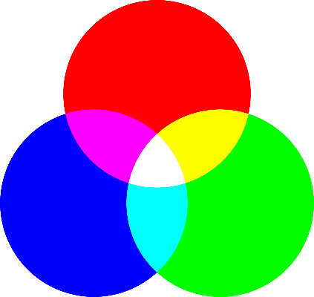
The diagram on the left shows all the different colors [wavelengths] in light and that white light is produced by a combination of all these colors, red, orange, yellow, green, blue, indigo and violet.
Red, green and blue are called the primary colors, and where two colors intersect they produce the secondary colors cyan, magenta and yellow, with which we are all familiar.

Below is the classic model showing how white light can physically be split into all colors by passing white through a prism.
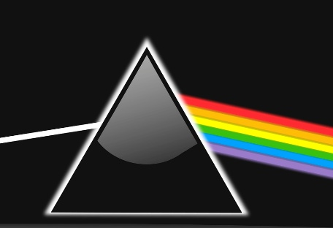
A rainbow occurs in nature when the individual raindrops act as prisms splitting white light into its constituent colors, in the order, of red, orange, yellow, green, blue, indigo and violet.

Nothing can be “pure white” other than the light that comes from the sun, and sunlight is actually white with a slightly blue cast. As sunlight passes through the atmosphere, the blue light within the white light is scattered and absorbed by the atmosphere, which causes the sky to appear blue. The red light part of sunlight remains relatively unaffected so the sun itself looks yellow.

Light alters depending on the time of day.

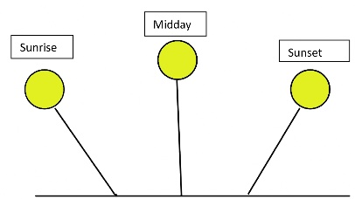
As you can see from the diagram on the left the rays from the sun hit the ground at different angles. At sunrise and sunset, the light from the sun passes through more atmosphere than at midday due to the angle with ground, so more blue light is absorbed on its way through the atmosphere making it look more red. As a result objects tend to have a color cast depending on the time of day.
Diagram 1

Some examples of subjects taken at different times of day and in different situations that shows how the light affects them.


The sea at midday when the light The sea at sunset when the light is
Is blue. warmer and more red.

Another factor affecting light color perception is a mechanism in the brain. The brain uses an adaptation with the color white. It is a dynamic process that allows human vision to maintain consistent color perception despite changing lighting conditions. So, for example, that when viewing a white object under different lighting conditions, such as yellow incandescent light, or blue daylight, white is always seen as white.
So why, if the brain is compensating this way, do we still see colors in white objects? We still see colors in white objects because this correction by the brain is not perfect. The brain attempts to interpret the scene as a whole rather than try to achieve absolute color accuracy. So the brain's white point correction is only a best estimate so that you can recognize objects.
How does light and the lighting conditions affect our perception of white?
The effect of light on white objects is exhibited by reflection and the color “temperature” of the light source. For the purposes of this article we don’t need to explore this in depth. Simply, color temperature measures the color of light uses a scale called the Kelvin scale. It ranges from low numbers, for warm (yellow/orange), to higher numbers for cool (blue/white). It defines the mood, with warmer tones for comfort, and cooler tones for daylight simulation.
Factors that affect the perception of white
1 Reflection- objects look white because they reflect all visible wavelengths [colors] of the spectrum.
2. Brightness- white reflects the highest amount of light which can create a very bright ambience. Intense direct light will appear washed out.
3. Color temperature absorption- white surfaces take on the color of the light shining on them.
Key Lighting Effects on White:
- Tungsten/Incandescent -Adds a strong, warm orange/yellow cast to white surfaces.
- Warm White LED/Halogen- Soft , “cosy”, and slightly warmer than neutral.
- Daylight/Direct Sun- Neutral white, which gives the most accurate color representation.
- Overcast/Cloudy – Adds a cool, blue cast to white.
- Shade - Produces a deep, cool blue effect, especially in open shade on sunny days.
- Fluorescent -Produces a harsh greenish or magenta tint, depending on the bulb.
Here are some images that show the effect of light at different times of the day. They are all snow scenes.

This is an image of snow at midday and passes through the least amount of atmosphere. [see diagram 1]. When sunlight enters a thick layer of snow or ice, the ice crystals absorb longer-wavelength light—specifically red and yellow light—more readily than shorter-wavelength light, blue.
Also in shaded areas, snow does not receive direct white sunlight. It is illuminated by the blue light scattered from the sky. This, plus the absorption of red light in the snowpack, makes shadows on snow appear very blue, especially to cameras.


This image was taken at late afternoon when the sun was lower in the sky. The light striking the snow appears red, orange, or gold, as it is passing through more atmosphere. [ see diagram 1].

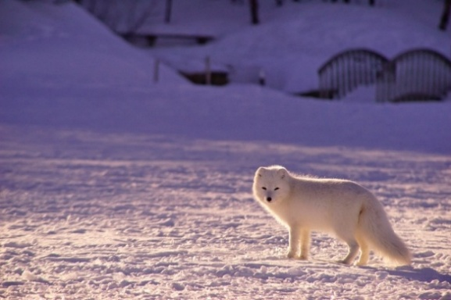
This image was taken close to night and there are lots of shadows.
Immediately after sunset or before sunrise, snow reflects the ambient twilight, which is has lots of blue light. Shadows in the snow at this time often appear as deep blue or violet


Closer to darkness the shadows deepen and the purples, blues and pinks intensify.

Note- In urban areas, snow can appear orange or pink due to light pollution, reflecting off low clouds, from streetlights, and buildings
So, these are the main features that can affect our eyes perception of white according to biology and physics.

Many of the reference sources artists use are photographs so a camera is involved in the image production.
So how does the camera see white?

Simply put, digital cameras have sensors that detect a balanced, equal amount of red, green and blue light. Unlike the human eye the camera lacks the ability of the brain to alter the “white point” but has an inbuilt automatic white balance [AWB]. AWB which sets color temperature automatically for most types of scenes. Many cameras have manual presets, such as daylight, cloudy, or set image types such as landscapes, close-up, flowers and so on, which adjust the white balance depending on the light source or subject selected. Some cameras also allow you to set an actual color temperature or select the light source, such as fluorescent, tungsten [ indoor lighting], daylight. Using these settings the camera can, to a great degree, remove unrealistic color casts. For example, indoor photographs often have a blue tinge, and the camera will remove this by adding yellow. As a result of how a camera sensor works, images with several white objects in the same frame are often displayed as different from each other, which require adjustments after the image is created. These are called color casts and they occur because the camera’s AWB mechanism fails when it has problems with mixed lighting conditions or intense colors.
So, how is the color white affected in the world of art?

Unlike in reality, where white is a combination of several colors, in the art world white is an absence of color. We can leave a blank space on white paper or we can paint the area using a white paint which contains various pigments to produce white.
In Nature white is never pure white. Painting layers of white alone will make a painting dull, lifeless, and flat.
So how can you produce a natural looking white in a painting when not using a photographic reference source?

- To simulate a cool northern light, add a cool yellow such as cadmium yellow light to white.
- For warm southern light, add yellow ochre to white
- Mix opposite colors, like yellow and purple, with the white to produce grays for shadows. These can be altered to make warmer or cooler shadows as needed.
- Make an object “pop” by surrounding it with dark colours to contrast with the white.
- Adding small amounts of blue or yellow to white will simulate daylight.
- Sunlit areas should contain hints of yellow, orange and red, to give warmth.
- Ligh shadows on white often contain cool colors such as lavender, soft greens etc, but never black.
- Dark shadows in real life are rarely black. These shadows often contain darker tones of the surrounding color, often dark blues, purples etc, but depend on the actual environment.

How do we best determine the colors in white when using photographs?

Firstly, we need to decide whether the image as a whole has a color cast resulting from issues with the camera, as discussed before, when the AWB system fails, or because it is affected by nearby colors etc.
Here is the original photograph of a white Swiss Shepherd dog taken with a mobile phone. Many photographic devices, cameras and phones, show color casts and a common one is yellow, and as you can see the grass has a yellow cast to it. So, I altered it by removing some yellow by moving the color temperature towards blue, its opposite color. This produced the image on the right and the grass looks greener. The white dog has not changed color as there is no yellow in it.

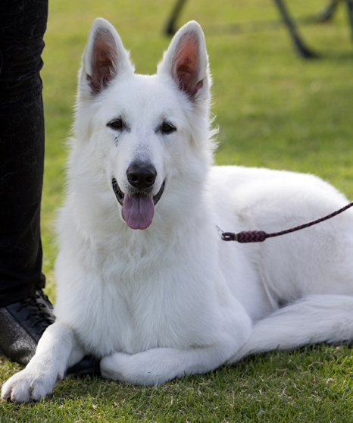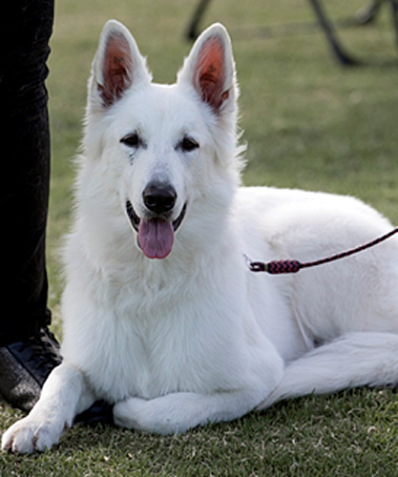
The white, as you can see, has other colors in it. Sometimes it I ea sy to see what colors are present but a good way to determine what the color/s are it to use a piece of whie paper with a small hole cut in it and move it around over the object.
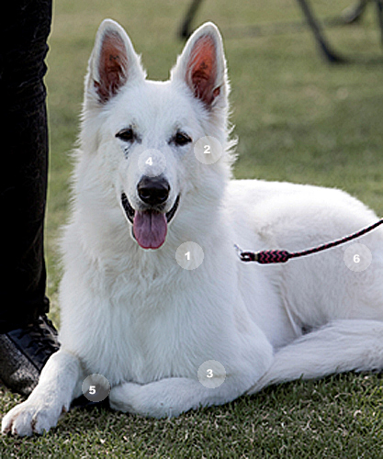

In this photograph I have marked seven circular areas where I used a white piece of paper with a circle cut out and took a photograph of each to check the color in the white. I marked the areas on the photograph and numbered them and the findings are shown below.

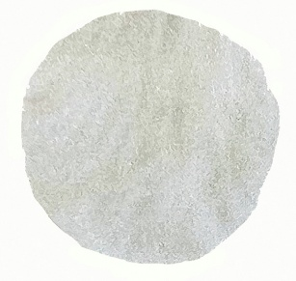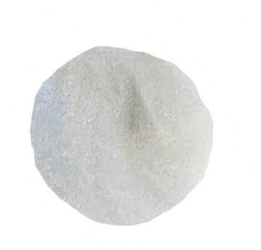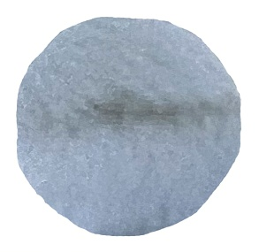
- There is yellow in this part of the coat.
- Similarly there is yellow here moving to blue towards the right side.
- Distinct blue in the coat, but the gap between the chest and paw is a brownish yellow.
- The area above the nose is mid blue with a little purple in it.
- 5.The are under the leg where it meets the ground is dark blackish brown.
- The coat on the back leg has a distinct magenta color.
1 2 3
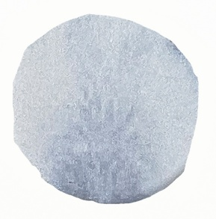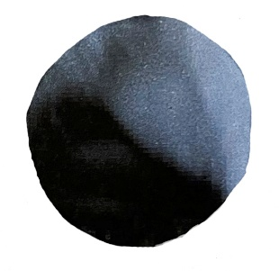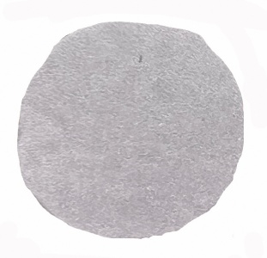
4 5 6
So, you can see by using this simple tool how easy it is to see a color cast anywhere in the reference photograph, but particularly on white.

I hope that you find you find something useful in this article to help with your art.
I wish you well in your art endeavours.
Geraldine

